**­­­**

Class 7

**Lecture 7**

**Web & Internet**

**Internet Basic**

**HTML**



**Lab Objectives:**

* Overview of Internet.
* Benefits of Internet.
* Internet Users.

**HTML Structure**

The Internet is a global wide area network that connects millions of computer systems across the world. More than 190 countries are linked into exchanges of data, news and opinions.

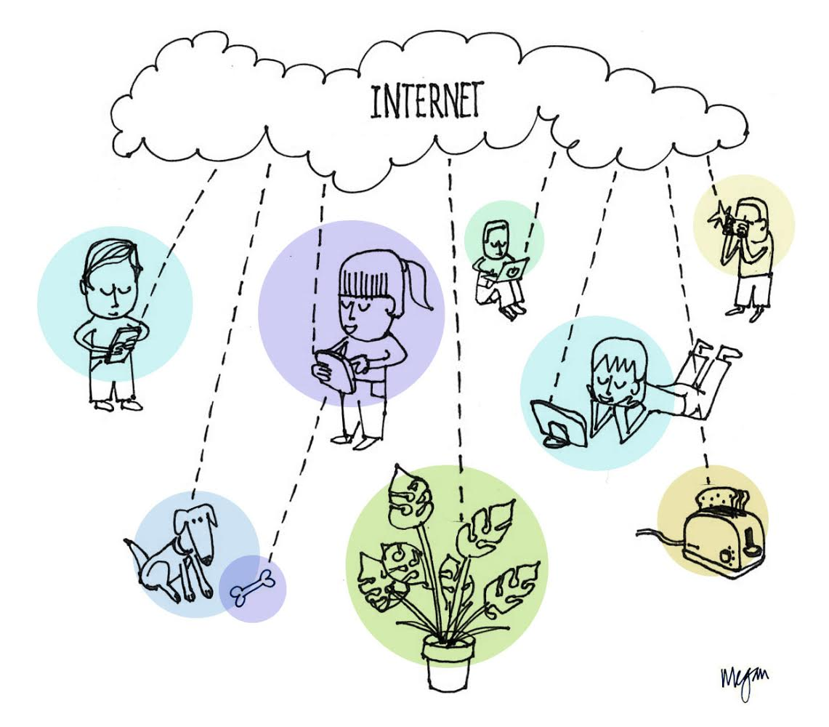

**Origin of Internet**

It was conceived by the Advanced Research Projects Agency (ARPA) of the U.S. government in 1969 and was first known as the ARPANet. The original aim was to create a network that would allow users of a research computer at one university to "talk to" research computers at other universities.

**Internet Connection**

The Internet is a global wide area network that connects computer systems across the world. It includes several high-bandwidth data lines that comprise the Internet "backbone." These lines are connected to major Internet hubs that distribute data to other locations, such as web servers and ISPs. In order to connect to the Internet, you must have access to an Internet service provider (ISP), which acts the middleman between you and the Internet. Most ISPs offer broadband Internet access via a cable, DSL, or fiber connection. When you connect to the Internet using a public Wi-Fi signal, the Wi-Fi router is still connected to an ISP that provides Internet access. Even cellular data towers must connect to an Internet service provider to provide connected devices with access to the Internet.

The Internet provides different online services. Some examples include:

* Web – a collection of billions of WebPages that you can view with a web browser
* Email – the most common method of sending and receiving messages online
* Social media – websites and apps that allow people to share comments, photos, and videos

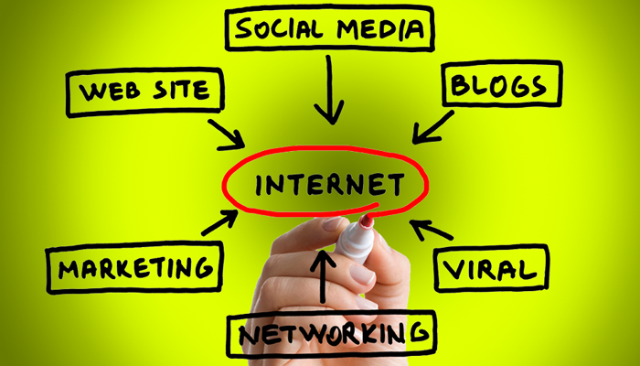

* Online gaming – games that allow people to play with and against each other over the Internet
* Software updates – operating system and application updates can typically downloaded from the Internet

**Owner of Internet**

No one actually owns the Internet, and no single person or organization controls the Internet in its entirety. The Internet is more of a concept than an actual tangible entity, and it relies on a physical infrastructure that connects networks to other networks.

**Benefits of Internet**

* Electronic Communications
* Online Shopping
* Online Banking
* Information Gathering and learning
* Connectivity, communication, and sharing
* News
* Globalization
* Social Networking
* Marketing.

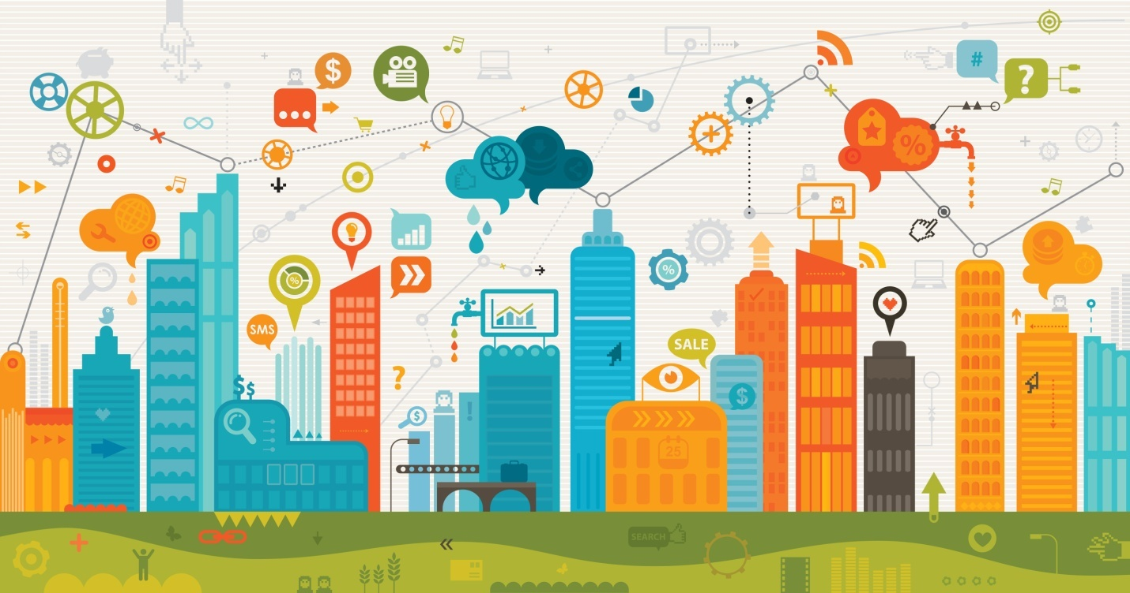

**Internet User**

The new 2018 Global Digital suite of reports from We Are Social and Hootsuite reveals that there are now more than 4 billion people around the world using the internet.

**Global digital population as of July 2018**

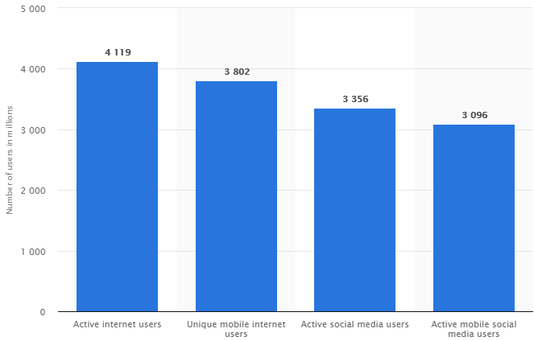

In our Country- The total number of Internet Subscribers has reached 83.141 million at the end of February, 2018.

